**DESI Commissioning Instrument Metrology Procedure R8**

**CI Metrology Outline**

1. Preliminary Measurements
   1. DMM Magnification (2 methods possible)
   2. 100u pinhole mapping onto STi method #1 in lab
2. CI Preparation
   1. Pre-set TTF plate gaps to compensate for different camera back-focus distances
   2. Select the “worst” FIFs for the ones that are installed on the TTF plate with the cameras
3. Install CI onto CMM
   1. Align CI on CMM using a mechanical Renishaw touch probe
   2. Define CS5 right hand Cartesian coordinate system origin as defined by steel of CI (aka “mechanical CS5 origin”)
   3. FIF Cap mechanical probing position measurement
4. Remove the Renishaw mechanical probe from CMM
5. Mount and Align DMM on CMM
6. Connect mechanical CS5 origin to DMM optical CS5 origin
   1. FIFs
      1. Take images of the FIF pinholes prior to any FIF adjustments (at their current focus position)
      2. Centroid all FIF pinhole images and calculate the Average position of the FIF pinholes on the STi CCD. This is the position of CS5 0,0 on the STi CCD (aka “optical CS5 origin”)
7. CCD Camera Measurement & Alignment (C, N, E, S, W) (5 Cameras)
   1. Measure and Align Tip/Tilt/Focus of 6303 CCD (Center first)
      1. Center CCD: Tip/Tilt/Focus/RZ metrology and adjustment
      2. Center CCD: Lock adjusters
      3. Calculate RZ of 6303 CCD (Center first)
   2. Map 100u pinhole onto STi Row/Column using retro-reflection off 6303
      1. 100u pinhole mapping onto STi Row/Column using retro-reflection off 6303
   3. Calculate the “Calibration Offset”
      1. Measure positions of as-built 25,25 pixel of 6303 CCD in Sti Row/Column Coordinates and transform to CS5 Coordinates
   4. Measure and Align Tip/Tilt/Focus of 6303 CCD (N,E,S,W)
      1. (N,E,S,W): Tip/Tilt/Focus/RZ metrology and adjustment
      2. (N,E,S,W): Lock adjusters
      3. Calculate RZ of 6303 CCD (N,E,S,W)
   5. Measure positions of center of 25,25 pixel of 6303 CCDs in Sti Row/Column Coordinates and transform to CS5 Coordinates
   6. Report position of CCD in CS5:
      1. 0,0 pixel and center pixel of active 3072x2048 image
      2. RZ angle
8. FIF Measurement & Adjustment of Focus and Pinhole Array Rotation
   1. Measure & adjust FIF focus (Z)
   2. Adjust pinhole array RZ rotation by rotating FIF mount (oddball inward)
   3. Make 4 pinhole centroid measurements for each FIF
   4. Find positions of FIF pinhole centers in Sti Row/Column Coordinates and transform to CS5 Coordinates by calculating and applying the difference between the FIF pinhole centroid and the “optical CS5 origin” (Note that this does **NOT** require application of the “Calibration Offset”)

**List of Acronyms**

CI Commissioning Instrument

CMM Coordinate Measuring Machine

DOF Degrees of Freedom

DMM DESI Metrology Microscope

FIF Field Illuminated Fiducial (illuminated pinhole)

STi CCD camera on the DMM (640 x 480 format) 7.4um square pixels

6303 CCD cameras on CI (3072 x 2048 format) 9um square pixels.

**Notes**

* All pixel coordinates refer to the center of the pixel
* Pixels are counted from 0, 0
* SBIG 6303 output FITS file is format
  + CCDOPS images which are 3100x2056 in size with overscans
  + Left = 16 Right = 12 Bottom = 4 Top = 4
  + 3072 x 2048 light sensitive pixels in full frame image (DOS Software uses this size)
* Z=0 for CS5 is 322.936 mm below the flange face of the Adapter Cylinder
* Center 6303 CCD surface to top of fixed TTF plate is 86.881mm
* Nominal gap between fixed and tilting TTF plates is 7.70mm for the Solidworks model nominal backfocus of 24.5mm

**Tools & Materials Needed**

* DMM mounting Requirements onto Ometek CMM
  + White disc on inside of LED cavity
  + Must match available hole pattern and piloting features on CMM arm
  + Must ensure that the DMM optical axis is well aligned to the Renishaw probe axis
    - Pre-align DMM with its CMM mount on lathe?
    - Provide Tip/Tilt adjustment of DMM
  + DMM mounting must be repeatable to ~ 0.2mm at focal plane of DMM
  + DMM mounting must be very rigid and stable.
  + DMM mount must also have a method to adjust and lock RZ angle of DMM to set STi camera rows parallel to 6303 camera rows.
* Mounting of CI onto CMM table
  + CMM table is steel with some tapped holes
  + CI metrology baseplate to stabilize CI
  + Shims for Tip/Tilt adjustment of CI on CMM table
  + Tangential “Pusher” to rotate CI in RZ
* Ring illuminator onto end of DMM to see 6303 CCD features
* Inspection mirror to see onto CCDs and into FIF tubes for FIF orientation
* Massive base (fixed depth OK) for digital indicator to place on TTF during adjustment

Tip/Tilt Pre- Adjustment for Camera Backfocus variations

* Dial caliper or gauge blocks to set TTF plate nominal gaps

FIF adjustment

* FIF special 5mm hex tubular wrench (thin wall to fit between DMM O.D. and FIF I.D.)
* 3mm Allen wrench for servo cleats
* 10mm open end wrench for FIF external hex jam nut

**Lab Measurements Prior to CMM Metrology**

**Measure DMM Optical Magnification**

Knowing the value of the optical magnification of the DMM is necessary because it is used to compute the “Calibration Offset”. Since the “optical CS5 origin” and the 100u pinhole position are both measured in a magnified image plane, they must be de-magnified to be used in CS5 coordinates.

**Method1:** This method compares the positions of 2 FIF pinholes in a single image. The advantage of this method is that it does not involve any CMM moves therefore does not have any error from a move. The disadvantage is that it requires unambiguous determination of which FIF pinhole is which.

1. Move the CMM to a position such that 2 pinholes are visible on the STi sensor.
2. Identify which pinhole they are by moving the CMM and looking at the with a mirror. This can be very tricky to determine unambiguously
3. Take an image and compute the centroid locations for both pinholes. Compute the magnified distance between the pinholes on the Sti sensor
4. Use the Yale lab data for the FIF pinhole locations to calculate the distance between the pinholes.
5. The quotient of the FIF pinhole centroid spacing and the CMM known distance is the optical magnification. Expected value is ~ 4.5.

**Method 2:** This method compares the positions of 2 FIF pinhole images displaced by a known amount by moving the CMM. The advantage of this method is that it does not require unambiguous determination of which FIF pinhole is which. The disadvantage of this method is that it does involve a CMM move therefore does have an error from the move.

1. Position the CMM such that an FIF pinhole image is near the left edge of the sensor. Take an image and determine the centroid location.
2. Move the CMM by a known amount (e.g. 800 micron) to move the FIF pinhole image to the right edge of the STi sensor. Take an image and determine the centroid.
3. Calculate the distance between the two centroids and
4. The centroids of the FIF pinholes are measured on the STi CCD and converted to um. The quotient of the FIF pinhole centroid spacing and the CMM known move distance is the optical magnification. Expected value is ~ 4.5.

**Map 100u pinhole onto STi Row/Column using retro-reflection off diffuse target or 6303 CCD surface**

**Method 1:** The 100u pinhole position reflected onto the STi CCD was mapped in the lab using a diffuse reflector and found to be at Xpix = 293.5 Ypix = 205.9 This mapping is an intrinsic property of the DMM and should be quite stable.

**Method 2:** It is possible to remap the 100u pinhole onto the STi CCD by reflecting the 100u pinhole at the time of the CCD TTF measurements (note that a specular reflector is OK for this because we are mapping an image plane to a magnified image plane, therefore tilts in the reflector do not move the image on the STi CCD).

1. 100 micron pinhole, Rseries = 1.0 kOhm VDC = **10 volt** for very bright 100u pinhole
2. Use ring LED light to illuminate 6303 surface
3. Open 6303 camera shutter
4. Turn on Sti camera in “full frame” mode to image surface of 6303 CCD (Texposure = 0.4 second)
5. Move CMM near to 0,0 corner of Center CCD at best focus
6. Move the CMM so that the 100u pinhole is reflecting off a flat and featureless area of the 6303 CCD. Take some images of the 6303 surface with the 100u pinhole.
7. Turn off ring LED light
8. Install black cover to darken the scene
9. Take several images of the 100 micron pinhole with the Sti camera.
   1. The centroid of the 100 micron pinhole is the mapping of the 100 micron pinhole onto the Sti CCD and is used for the Calibration offset.

**Install CI onto CMM**

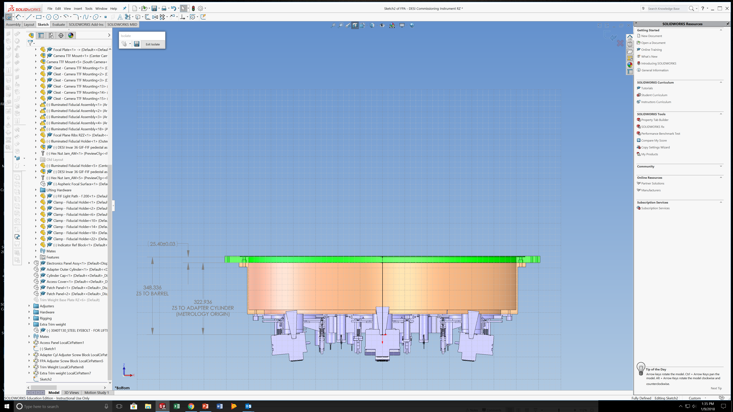

1. Mount CI using standoffs to CI metrology base. This base will be a steel disk with three adjustment screws to adjust the TIP/TILT of the CI on the CMM table
   1. Standoffs of ???? length will be attached to ribs on bottom of focal plate. This will give adequate access under the CI to adjust the TTFs and FIFs
2. Place CI on CMM table. Cameras are facing ceiling
   1. Adapter Cylinder will already be pinned and bolted to Focal Plate
   2. Verify that the CI on its metrology base is very stable on the table

**Align CI on CMM using a mechanical Renishaw touch probe**

All 6 Degrees of Freedom (DOF) (X, Y, Z, RX, RY, RZ ) of the CI must be located on the CMM. A standard Renishaw touch probe can be used to check all of these DOFs.

We may wish to mount the single TTF to some type of baseplate at OMETEK

**Define CS5 right hand Cartesian coordinate system**

* X=0 Y=0 is located at center of CI Adapter Cylinder outer edge
* The X,Y plane is parallel to the flange face of Adapter Cylinder
* The X,Y plane is tangent to the focal surface and approximately coincident with the center of the center CCD
* Positive X always points toward the EAST camera
* Z=0 for CS5 is 322.936 mm below the flange face of the Adapter Cylinder

1. RZ alignment of CI
   1. Rotate the CI to align CS5 X axis to the CMM X axis. Rotation is based on Adapter Cylinder dowel pins.
   2. Use a Renishaw probe to find the locations of 2 dowel pins on Adapter Cylinder and compute RZ angle
   3. Will need a tangential “pusher” to achieve required precision
   4. Tolerance on the RZ angle (+/- 100 micron at rim to match pre-calculated positions of FIFs and CCDs.
      * Note dowel pins are post-drilled and tolerance may be ~ +/- 50 to +/- 100 microns
2. Z and RX and RY Alignment of CI (Tip & Tilt)
   1. Using a Renishaw probe measure the Z depth of several points on the upward facing face of the Adapter Cylinder.
   2. Tip & Tilt the Adapter Cylinder to null (with shims or CI metrology base??)
   3. Face of Adapter Cylinder is now parallel to CMM granite table
   4. Set the CMM Z value at Adapter Cylinder face to +322.936 mm to establish CS5 “Z”
3. X and Y Alignment of CI
   1. Determine the CI center using the OD of the CI Adapter Cylinder (the reference dowel pins are post-drilled and therefore are not accurate enough)
   2. “Zero” the CMM X and Y values at CI center to establish “mechanical CS5 origin”

**FIF Cap mechanical position measurement**

1. Measure the positions of the ~ 20 FIF Caps with the Renishaw probe. The probe should touch the FIF Cap 3mm below the face of the Cap.
2. Select the ~ 20 best FIFs with the best centration of the center pinhole to the body based on Yale supplied data. These FIF pinhole body centers nominally have the exact same X,Y coordinates as the optical pinholes. FIFs are concentric. The errors are random and will cancel.
3. This Cap position data will be used together with the center pinhole centroid data (taken later) to find the statistical Average position of the pinholes (and assuming Cap to pinhole concentricity) and Caps on the Sti DMM CCD.

**Remove the Renishaw mechanical probe from CMM**

**Mount and Align DMM on CMM**

1. The rotation of the DMM on the CMM “toolholder” must be aligned and locked.
   1. The angle tolerance can be a few pixels off over the width of the sensor (this tight angle tolerance allows us to apply the Calibration Offset without a ROTATION transformation from Sti to CS5)
   2. The absolute stability of the DMM rotation must be sub-pixel over the width of the sensor for the entire measurement campaign.

**Connect mechanical CS5 origin to DMM optical CS5 origin**

This procedure is executed to transfer the Renishaw CS5 probe coordinates to the DMM optical probe CS5 coordinates. The mechanical positions of the FIF Caps were measured with the Renishaw probe in a previous step. The DMM optical probe locates the FIFs by imaging their center FIF illuminated pinholes onto the STi camera and locating the pinhole image centroids in Row,Column coordinates. Note that locating the CS5 “optical origin” must be done every time the DMM is re-mounted to the CMM.

1. RX, RY, RZ, do not need to be connected to the DMM as they are nulled angles
2. Z Connection
   1. Focus ST-I camera onto the machined texture of the Adapter Cylinder flange. Set this position to Z = +322.936 mm
3. X, Y Connection using FIF Center pinholes

The FIF center pinhole measurements must e done prior to any adjustments of the FIFs to preserve the positions they were in when their Caps were mechanically probed.

* 1. Move the CMM to the nominal CS5 X,Y coordinates for each FIF Cap
  2. Measure the Row, Column positions of the center pinhole image centroids of all FIFs that were previously measured with the Renishaw probe. These FIF pinhole centers nominally have the exact same CS5 X, Y coordinates as measured by the Renishaw (assumes FIF pinholes are concentric to their Caps).
  3. Calculate the Average value of the Row/Column position for all the measured FIF pinhole centroids. This is the location on the DMM STi CCD where “mechanical CS5 origin” maps (aka “optical CS5 origin”).

**CCD Camera Measurement & Alignment (C, N, E, S, W) (5 Cameras)**

The Center CCD is aligned first. Then the 100u pinhole is mapped. Then the (N, E, S, W) are aligned

**Measure and Align Tip/Tilt/Focus of 6303 Camera (Center first)**

1. 100 micron pinhole, Rseries = 1.0 kOhm VDC = 2.2volt Texposure = 0.4 second (minimum exposure time of 6303)
2. Use the CI 6303 camera under test in the “planet” mode to reduce image size and to get better focus curves using STDDEV method
   1. The offset of the starting row and column is given in the FITS header.
   2. XORGSUBF and YORGSUBF are the X and Y offsets of the subframe
3. Measure Z position (using STi imaging for rough focus and focus curves for final focus) of the 3 wee triangle vertex points **a,b,c** on the CCD
4. Use focus curve from + 400u to -400u in 100 micron steps.
5. Compare the measured position of the CCD to the nominal desired position of the CCD
6. Compute the required movements of the 3 TTF micrometer actuators **A,B,C** to place CCD at its nominal location
7. Execute the three micrometer actuator moves
8. Lock the **A,B,C** actuator screws
9. Repeat measurement of Z position of 3 points **a,b,c** on CCD wee triangle
10. Confirm that CCD is now located axially within tolerance (+/- 50u ) relative to nominal desired position
11. Compute the centroids of **a,b,c** using the images from best focus for each position

**Predict position of 25, 25 pixel of 6303 CCDs in 6303 Coordinates and transform to CS5 Coordinates**

Measurements of the positions of points **a,b,c**  are taken in 6303 coordinates along rows and columns.

Moves to 25,25 are made with the CMM along CS5 axes.

The 6303 CCD is rotated slightly relative to CS5 because perfect alignment is not realistic.

Therefore we must rotationally transform the coordinates from 6303 to CS5.

1. Calculate CS5 coordinates of 25, 25 pixel center from centroid information (in 6303 coordinates) for three points **a,b,c**  (which is in 6303 coordinates)
   1. Calculate dX and dY from points **a,b,c** to 25,25 in 6303 mm (using PlanetMode offsets and pixelSize and target pixel)
      1. dX = ((centroid(pixel) + planetModeOffset(pixel) - targetPixel(pixel))* pixelSize
      2. dY = ((centroid(pixel) + planetModeOffset(pixel) - targetPixel(pixel))* pixelSize
   2. Transform dX and dY from 6303 coordinates to CS5 coordinates using ROTATION coordinate transformation and the measured signed variable **RZ**.
   3. Apply the CS5 dX and dY values from each of the 3 points (**a,b,c** ) to predict 3 times the location of the target pixel. The separate predictions should agree very well.
2. Move CMM from a vertex point to nominal position of 25,25 pixel center using calculated CS5 dX and dY moves
   1. Project 100u pinhole onto 6303 CCD and take exposure and find centroid
   2. Compare this measured position of the 100u pinhole to the calculated position for pixel 25,25. They should be close
   3. Repeat this 3 times for **a,b,c** and average the results to calculate the position of 25,25 in CS5
   4. May be able to roughly count pixels to confirm 25, 25 pixel location

**Calculate the “Calibration Offset”**

The “Calibration Offset” is the vector between the FIF center pinhole centroids (“optical CS5 origin”) and the 100u pinhole mapping on the Sti. In order to transform the 6303 CCD positions measured with the 100u pinhole, the Calibration Offset must be applied. (An assumption is that the Sti rows/columns are aligned with CS5 axes).

1. Subtract the position of the “optical CS5 origin” and the 100u pinhole position in Row/Column coordinates.
2. Muliply by the STi CCD pixel pitch (7.4 micron) to convert the calibration offset to “magnified” microns
3. Divide this distance by the DMM optical magnification to convert to microns

**Apply the Calibration Offset**

1. Apply the Calibration Offset to transform the location of pixel 25, 25 from the location of the 100u pinhole retro-reflected onto the STi to the position of the FIF pinhole on the STi (optical origin)
2. Move CMM to the CS5 computed location for the 25,25 pixel with the Calibratio Offset applied
3. Take image of 6303 CCD surface features with STi camera
   1. The 25, 25 pixel should now be on the same STi Row/Column (as displayed on the monitor) as the “optical CS5” (from FIF pinhole centroids). This confirms that the signs and magnitudes of the Calibration Offset are correct.

**Calculate & Report CCD Coordinate Results**

1. Calculate position of 0, 0 pixel of 6303 CCD in CS5 coordinates
   1. This can be done using 4 independent inputs
   2. Must ROTATE coordinates from 6303 to CS5
   3. Point **a** to 0,0 Point **b** to 0,0 Point **c** to 0,0 and centroid of **25, 25** to 0,0
   4. All four should compute the same coordinates for 0, 0. Perhaps the average value will be best.
2. Calculate position of the center pixel of the 6303 CCD in CS5 coordinates. (Note center of CCD is not at center of the **a,b,c** triangle)
   1. 6303 image size in CCDOPS images is 3100x2056 in size
   2. This can be done using 3 independent inputs and prior knowledge of nominal triangle geometry
   3. Point **a** to CCD center (8mm offset vertical)
   4. Point **b** to CCD center (8mm offset vertical and 9.238mm offset horizontal)
   5. Point **c** to CCD center (8mm offset vertical and 9.238mm offset horizontal)
   6. All three should compute the same coordinates for CCD center. Perhaps the average value will be best.
3. Correct for Different image sizes in CCDOPS and DESI DOS
   1. 6303 image size in DESI software is 3072 x 2048
   2. 6303 image size in CCDOPS images is 3100x2056 in size
      1. horizontal over-scan is 14 columns Left & Right ???
      2. Vertical over-scan is 4 rows Top & Bottom ???
4. Report the RZ rotation angle of the CCD relative to CS5 using **b, c** centroid data taken above

**Measure and Align Tip/Tilt/Focus of 6303 Camera (N,E,S,W)**

1. The 6303 Cameras (N,E,S,W) are tilted by 5.4 degrees from the Z axis. Therefore when the CCDs are viewed from above, and measurements are made in the CS5 X,Y plane, the 6303 CCDs will appear to be fore-shortened across their width for all four cameras.
2. Magnitude of this fore-shortening is ~ (1- COS(5.4deg)) *(2048*9um) = 82 um (too large to ignore)
3. Repeat sections above (excluding calibration tasks) for (N,E,S,W) cameras

**FIF Measurement & Adjustment of Focus and Pinhole Array Rotation**

1. 10 micron FIF pinhole (note that there is no built-in series resistor in the FIF assemblies)
   1. FIF intensity can be set from 0 to 100 in DOS software
   2. Rseries = 20 kOhm VDC = 5volts Texposure = 0.02 second for manual mode
2. Use images from the ST-I camera on DMM in “full” mode to eliminate need to keep track of offsets. (Note: May need to use “planet” mode to select a single pinhole in some cases )
   1. The offset of the starting row and column is given in the FITS header
   2. XORGSUBF and YORGSUBF are the X and Y offsets of the subframe
3. Measure Z position of FIF center pinhole using focus curve
   1. -150 -100 -50 0 +50 +100 +150 positions should be adequate
4. Compare the measured Z position of the FIF to the nominal Z position of the FIF
5. Adjust FIF Z position by rotating FIF in its threaded cell (pitch = 500u per revolution)
6. Check FIF pinhole array RZ with inspection mirror
7. Rotate FIF Cell so that the three horizontally aligned pinholes are tangent to the CI perimeter and the “oddball” pinhole is oriented radially inward
8. Repeat FIF focus curve to confirm that FIF is still located within tolerance relative to nominal desired Z position

**Find positions of FIF pinhole centers in Sti Row/Column Coordinates and transform to CS5 Coordinates**

1. Move CMM to nominal FIF pinhole location
2. Use centroid software to find position of all four FIF pinholes in row/column coordinates of ST-i camera
3. Apply the Calibration Offset to transform the location of FIF from STi Row/Column to CS5 coordinates

**Repeat TTF carried FIF to 6303 camera location measurements**

The tolerance on the position of each 6303 camera CCD to its nearest FIF is the tightest metrology tolerance. In order to reduce the errors the measurement it will be repeated several times.

* Re-measure TTF carried FIF center pinhole centroid at its best focus CS5 focus value
* Re-measure the 6303 camera positions at **a,b,c** points and 25, 25 point. Then recalculate 0,0 and center coordinates in CS5

Repeat these measurements several times to hopefully reduce error by root N.

**Audit Acquired Measurement Data**

1. Independent effort to spot check and verify some CCD and FIF coordinates
2. Offsets
   1. 100 micron pinhole projected onto ST-i camera (Measured by retroreflection in lab and on CI)
   2. Calibration Offset (100u retro-reflection location on STi to FIF center pinholes location on STi)
   3. Subframe relative to CCD full frame origin (header of FITS files)

**Appendices**

**Measured Backfocus of 5 CI cameras (03/05/18)**

* Nominal backfocus of cameras used in Solidworks model is 24.5??
* N: 24.658mm
* W: 24.455mm
* S: 24.500mm
* E: 23.851mm
* C: 23.960mm

|  |  |  |  |
| --- | --- | --- | --- |
| **Camera Backfocus**  **Pre-set Gaps** | |  |  |
|  | 24.5 | Nominal Backfocus in SW model | |
|  | 7.7 | Nominal Gap between fixed plate and Tilting Plate | |
|  |  |  |  |
|  |  | **"Shim"** | **Preset Gap** |
| North |  | 0.158 | 7.858 |
| West |  | -0.045 | 7.655 |
| South |  | 0.000 | 7.700 |
| East |  | -0.649 | 7.051 |
| Center |  | -0.540 | 7.160 |
| Average | 24.285 |  |  |

**RZ Sign Determination Conditional Tests**

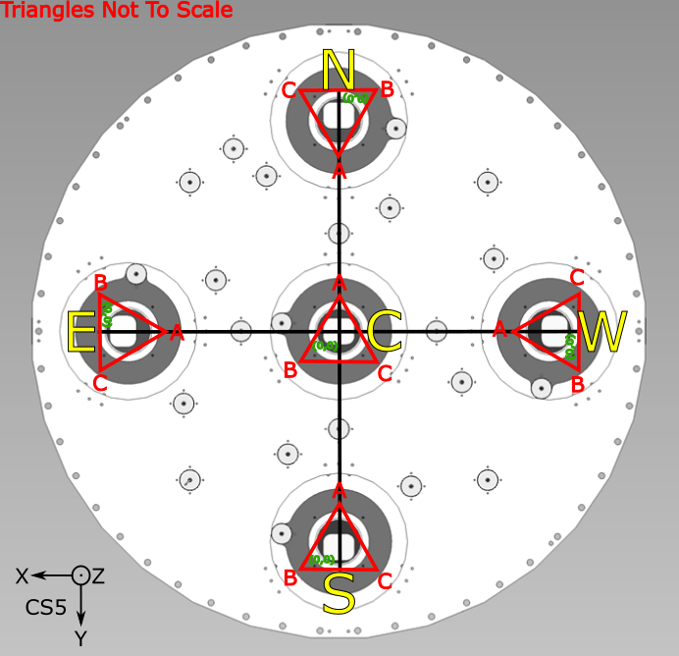

**C N E S W Cameras**

The arguments for the conditional tests below ( b(y) and c(y) ) are 6303 column pixel values for the centroid location of the 100u projected pinhole at that vertex points **b,c**. The nominal value for the pixel values of b and c are ~ 135 pixels from the long outside edge of the CCD

Because the 6303 cameras and the **a,b,c** triangles rotate together, the same identical RZ conditional test applies to all 5 cameras

Example for the Center camera : b(y) = 120 pixel c(y) = 150 pixel

b(y) < c(y) Then RZ is negative

**Conditional Test**

The **a,b,c** triangle edge **b,c** is parallel to a CS5 axis (X or Y) and serves as the reference line for RZ angle

Positive RZ is defined by right hand rule around CS5 Z axis.  Counter-clockwise is positive

**Case1:**  6303 is rotated positive (CCW) relative to bc

Conditional Test: **IF b(y) > c(y) THEN   RZ is positive**  (Counter-Clockwise)

**Case2:** 6303 is rotated negative (CW) relative to bc

Conditional Test: **IF b(y) < c(y) THEN   RZ is negative**  (Clockwise)

**Questions & Concerns**

* CMM
  + Does the CI fit on the RS70 CMM?
  + Can we probe points on OD of Adapter Cylinder (or Focal Plate) to establish CS5 0,0
* CMM probes
  + Can the OMETEK CMM probe reach into our FIF holders?
  + Tolerance on the RZ angle of CI on CMM??
    - How well does the blind pointing position to the FIF Cap need to be for Renishaw probing?
* CI Hardware
  + How close to being centered must the FIF center pinhole image be to its Cap? Average the values of the best FIFs)
* DMM Hardware
* Functional requirements for mounting DMM to CMM
  + Adjust mounting angles (Rx, Ry) of DMM (after Renishaw probing is complete) to insure that the center FIF pinhole is near the center of the STi sensor?
  + Adjust mounting angles (Rz) of DMM to align Sti rows and columsn to CMM X and Y axes
* Centering of pinhole to OD in possible with custom Illuminated dowel pins

**3/28 Notes**

* Must OPEN 6303 shutter to see CCD structure
* The TTF assembly procedure must include a step to set the gap between the moving and stationary TTF plates to the nominal value of 7.7mm
* “Planet” mode of CCDOPS must be used for the A,B,C focus curves. However at least one full frame image should be stored to disambiguate the pinhole position at each of the triangle points
* The actual CCD surface was fairly close to the expected nominal depth of 88.?? from the top of the fixed TTF plate (as probed by the Renishaw) to the best focus of the sensor
* The TTF actuators move 1/80” per revolution.  There are 50 tick marks per revolution on the micrometer barrel
* Using a digital depth gauge to measure the actual movement NEAR (not quite at) each of the three actuator points (A,B,C) may be a very valuable aid. Definitely works well here.  Should develop a lighter weight support for the indicator so it is easy to move with one hand

**Tasks**

-          Execute the predicted adjustments and get the CCD within tolerance (+/- 50 microns) in Tip/Tilt/Focus

-          Try to align the FIF in Z and rotation

- measure CCDlocation , RZ, 0,0

**3/30 Notes**

* The image of the 6303 CCD structure on the STi moves when rotating a TTF actuator. This is likely due to runout of the screw. This will confound alignment. Screws must be locked after TTF adjustments are in range to prevent any CCD in-plane translation.